CPE301 – FALL 2019

Design Assignment 2A

Student Name: Brysen Kokubun

Student #: 2001009068

Student Email: brysenkokubun96@gmail.com

Primary Github address: https://github.com/bkokubun99/Submission_DesignAssignments

Directory: <https://github.com/bkokubun99/Submission_DesignAssignments/tree/master/DesignAssignment_2A>

1. **COMPONENTS LIST AND CONNECTION BLOCK DIAGRAM w/ PINS**

Atmel Studio 7.0 Atmega328PB-Xmini PC Multi-Function Shield Logic Analyzer

- Assembler - Switches

- Simulator - LEDs

- Debugger

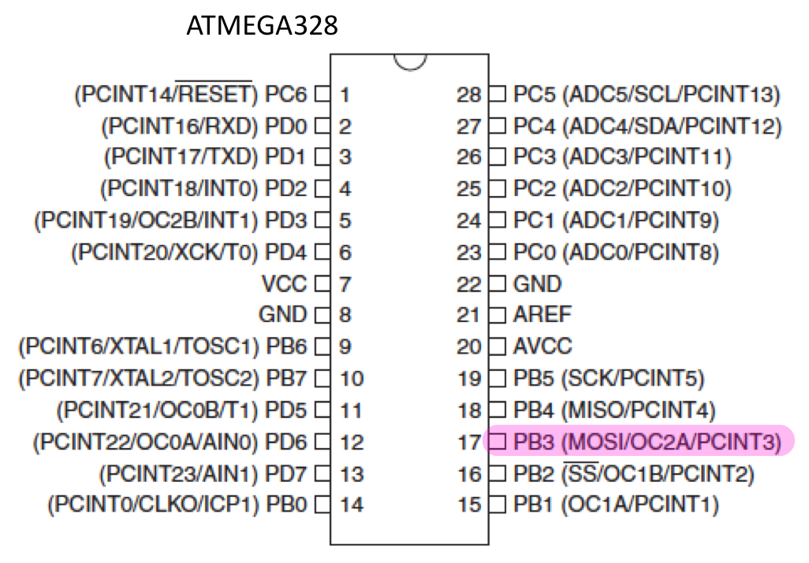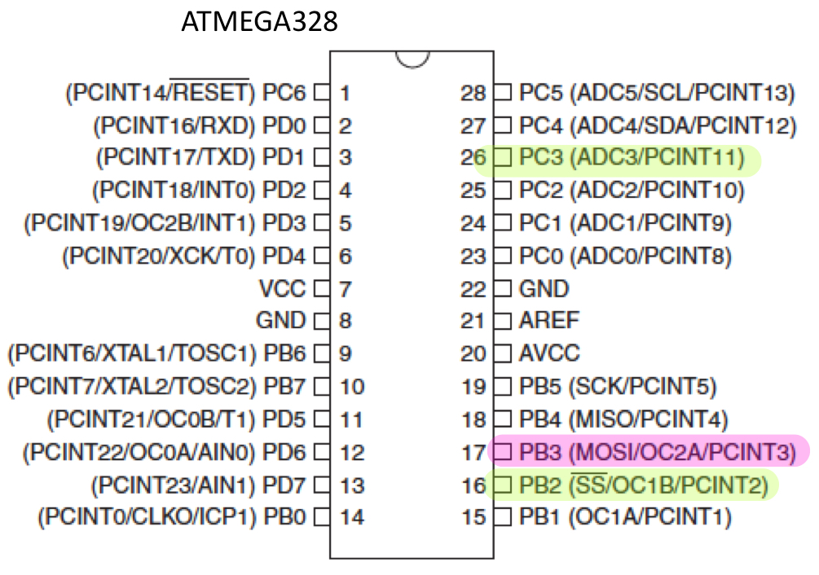

Port Pins used for 2A Part2

Port Pins used for 2A 1

1. **INITIAL/MODIFIED/DEVELOPED CODE OF TASK 1/A**

Assembly Code for Task 1A

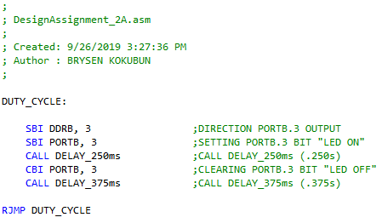

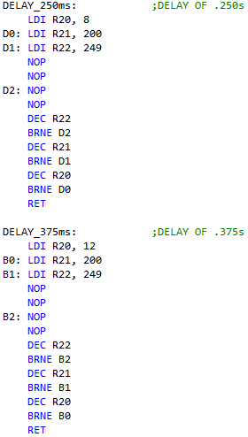

C Code for Task 1A

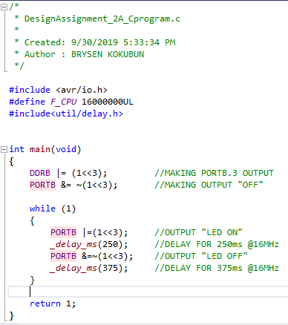

1. **DEVELOPED MODIFIED CODE OF TASK 2/A from TASK 1/A**

Assembly Code for Task 2A

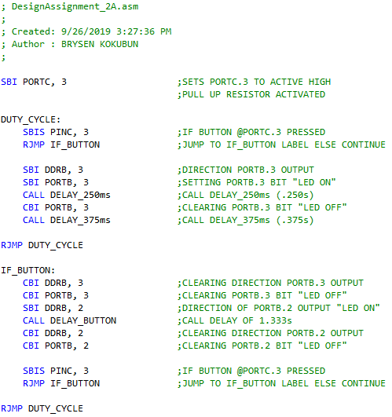



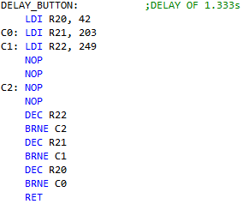

C Code for Task 2A

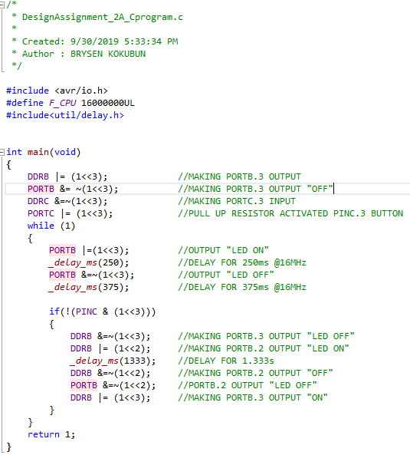

1. **SCHEMATICS “Using Fritzing”**

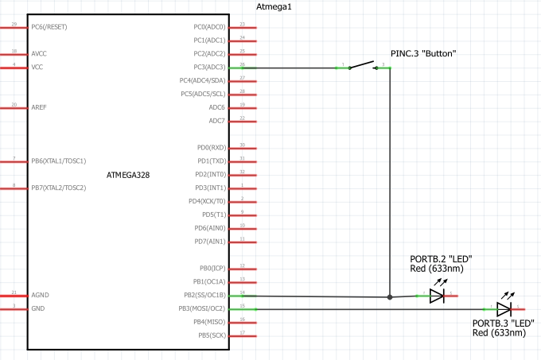

1. **SCREENSHOTS OF EACH TASK OUTPUT (ATMEL STUDIO OUTPUT)**

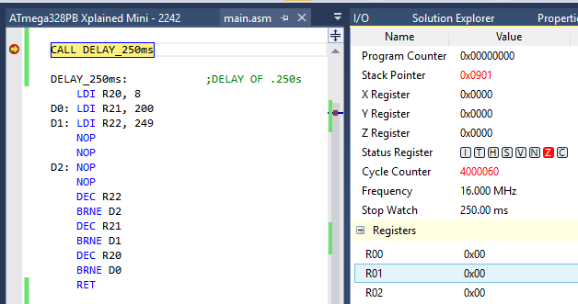

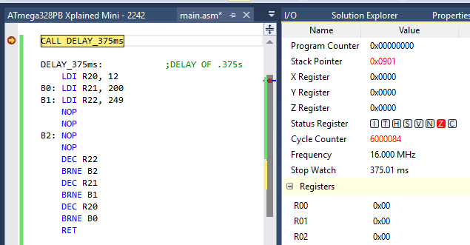

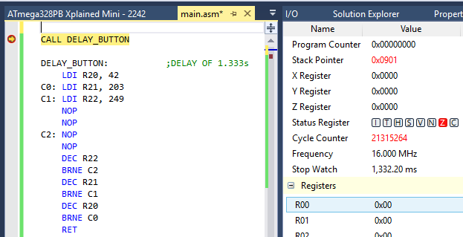

Here are the output waveforms from using the logic Analyzer to test the Duty Cycle and the number of seconds the light would be ON and OFF. Since the logic analyzer software was only at 8MHz frequency, the number of seconds shown below will have to be multiplied by 2 in order to get the values for 16MHz.

0.125s * 2 = 0.250s “ON”

0.1875s * 2 = 0.375s “OFF”

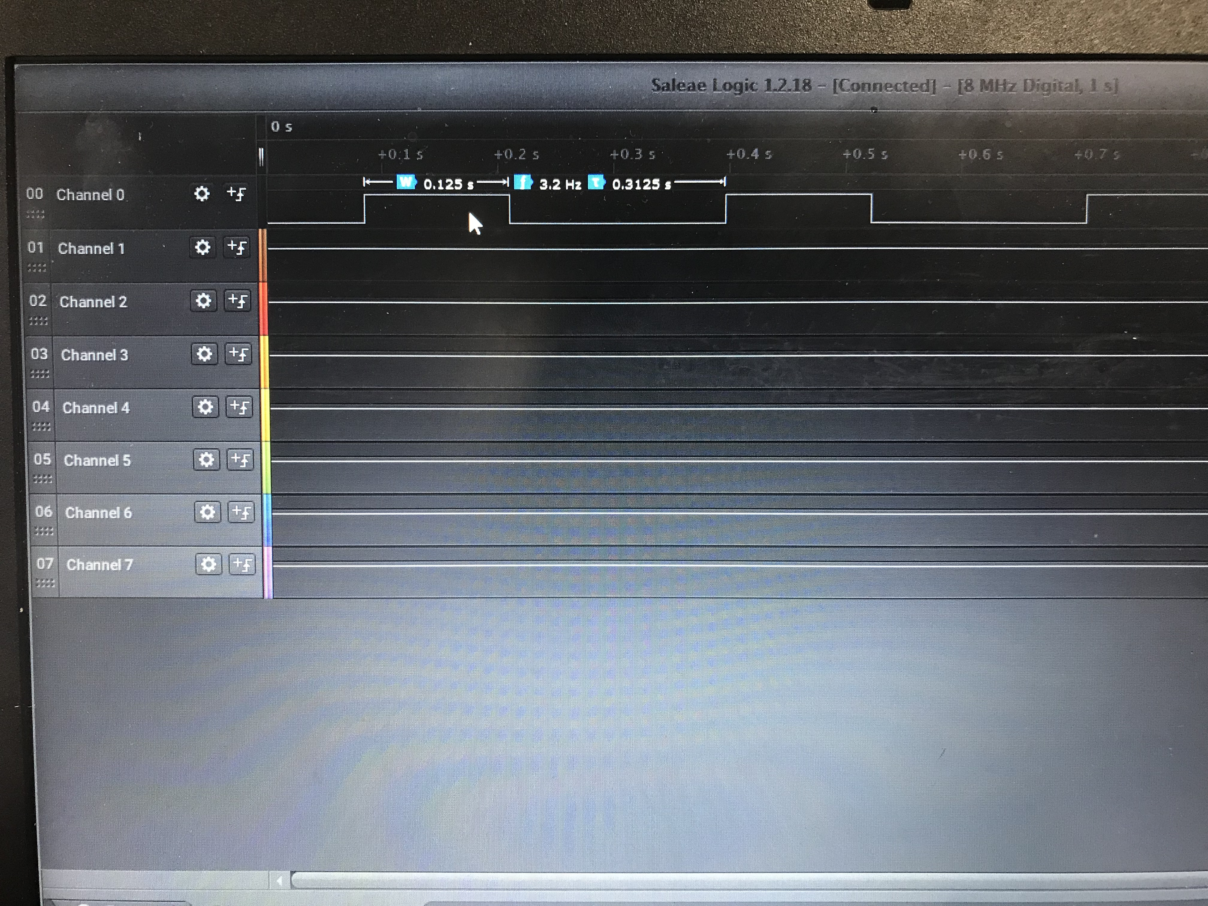

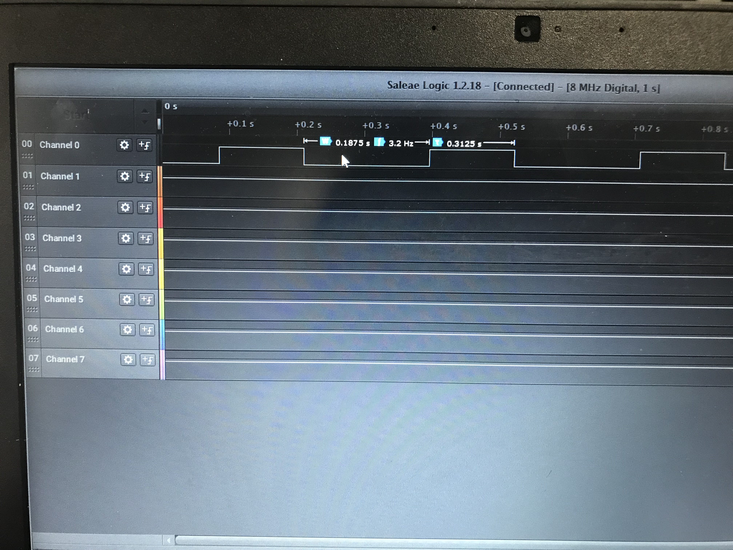

1. **SCREENSHOT OF EACH DEMO (BOARD SETUP)**

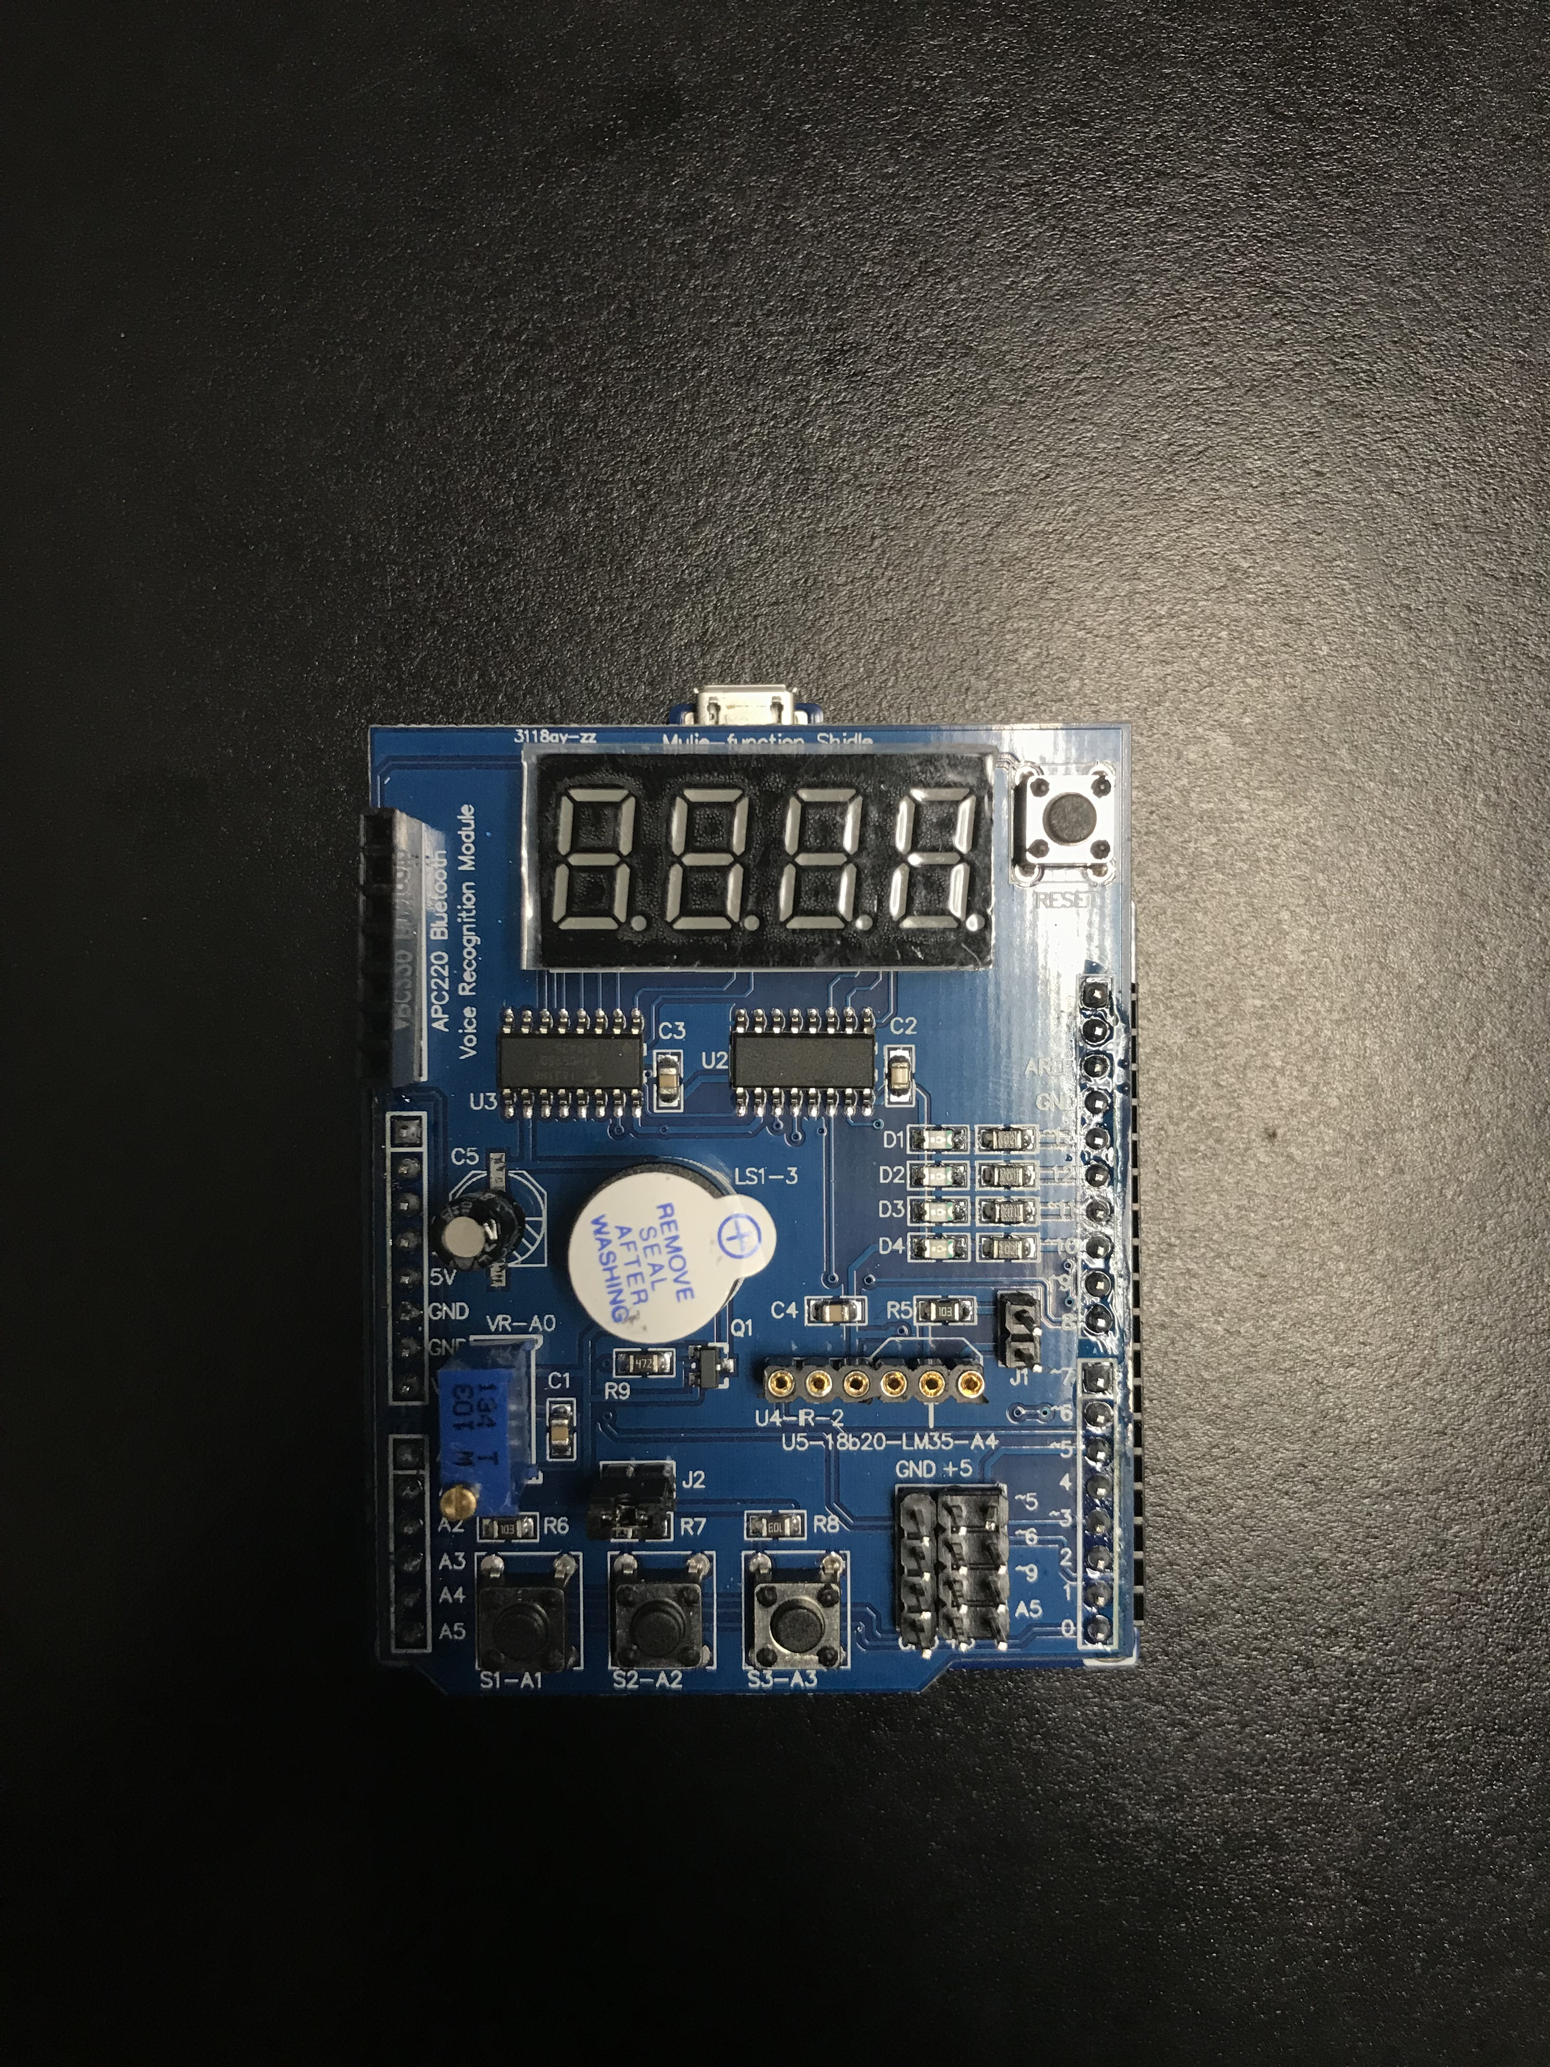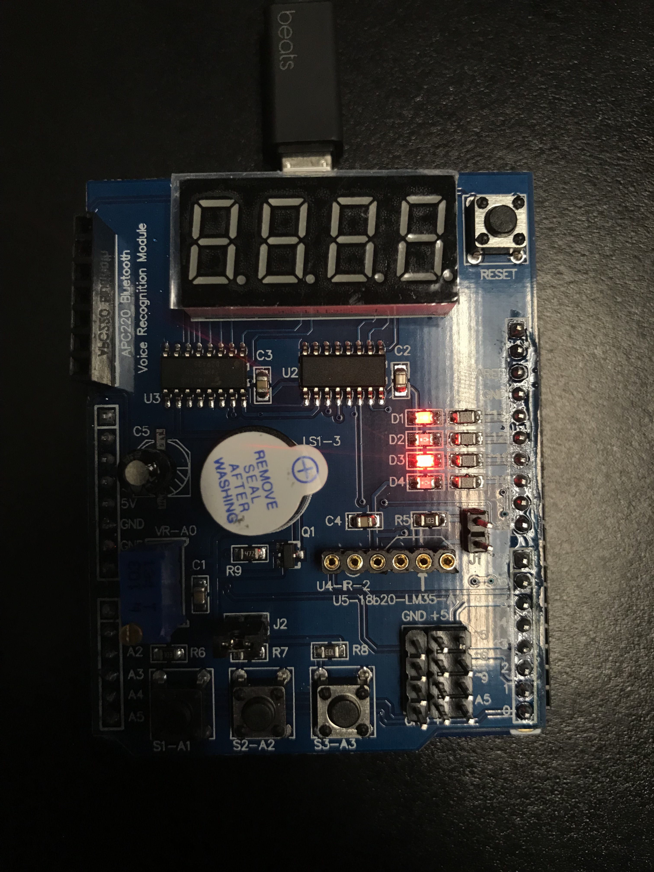

1. **VIDEO LINKS OF EACH DEMO**

Assembly Program Demo Video

<https://youtu.be/zHrgpIRTYmA>

C program Demo Video

<https://youtu.be/oC0kgvT_ovw>

1. **GITHUB LINK OF THIS DA**

<https://github.com/bkokubun99/Submission_DesignAssignments/tree/master/DesignAssignment_2A>

**Student Academic Misconduct Policy**

<http://studentconduct.unlv.edu/misconduct/policy.html>

“This assignment submission is my own, original work”.

Brysen Kokubun